10 Way Horizontally Mounted Rackmount IEC 14 Plug PDU - IEC 13 Sockets (PDU-10WS-H-IEC-IEC)
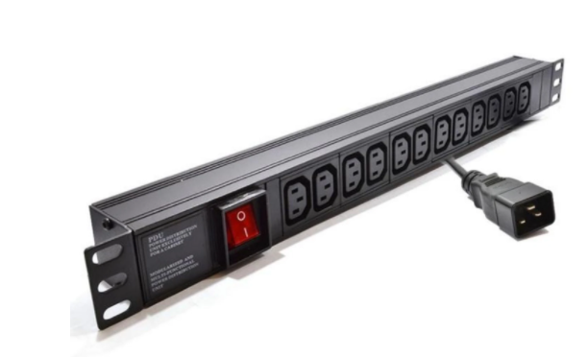

Description:
The LMS Power PDU-10WS-H-IEC-IECis a high-quality horizontally mounted PDU (Power Distribution Unit) that simply fits within the universal mounting brackets of data, telecom and server cabinets.
A must-have accessory for your data cabinets if you need to provide effective power to devices including Ethernet Switches, Servers, UPS, NAS and of course cabinet accessories including cooling fan trays.
Robust, alloy design complete with rackmount brackets fitted, high-quality Neon Switch, standardised IEC 13 power outlets, the PDU being fitted with a standardised IEC 14 Plug.

Key Features:

Standard IEC 13 power outlets for your appliances
Standardised IEC 14 power plug
1U horizontally mounted attaches to internal profiles
Neon On/Off Rocker switch to prevent accidental turn off
Backed up by LMS Power's exclusive 3-year warranty

Applications:
Create instant power feeds to your data, telecom or server cabinets
Provide effective power for cabinet cooling fans, UPS systems
Ideal as stand-alone trailing sockets outside the cabinet

Product Code:
Part Number: PDU-10WS-H-IEC-IEC
EAN: 8400800036100
Weight: 1.4Kg approx

Technical Specifications:
Warranty LMS Data 3-Year Warranty
Chassis 1U horizontally PDU with mounting brackets
Output Sockets 10 IEC 13 Sockets
Power Input Standardised IEC 14 Plug
Flex Length 2 metres (approx)
Power Control On/Off Rocker Switch (illuminated)
Power Rating 4000 Watts (approx) Surge Protected

Supplied With:
PDU-10WS-H-IEC-IEC 10 Way Horizontal PDU
Cabinet brackets (Fitted)
* Specifications and product design are subject to change. E&OE.

Looking for highperformance power distribution for your heavily loaded systems? The newly developed LMS Data 10A heavy-duty horizontal PDU using the modular IEC-14 input connector which is ideal for many device requirements including server, network and other industrial-type equipment functions such as broadcast and HVAC applications. Combining a fully certified IEC-14 plug input combined with a compatible heavy load power flex means you can be assured this LMS Data PDU can work without problems, 24/7. Furthermore, incorporated onto the horizontal form-factor are industry standard IEC-13 sockets, ideal for data, telco and broadcast equipment with the added benefit of integral electrical surge protection. Robust in design, with an integral neon illuminated rocker switch for assured functionality, the LMS Data PDU is designed to deliver maximum electrical power today and tomorrow.

specifications:
Horizontal, high-density Power Distribution Unit (PDU)
Modular 10A IEC-14 style plug format
Compatible, heavy-load power cable
8x IEC-13 output power sockets
Robust, black aluminium design for industrial use
Neon on/off power switch for assured control
Maximum power rating - 4000W
2.0 metre (approx.) power cordage
Ideal for data, telecom, broadcast and HVAC applications

